HOW TO: SET UP YOUR FOOD CORRIDOR ACCOUNT AND SUBMIT REQUIRED PAPERWORK
- Follow the link provided by STL Foodworks management. Management will also provide the STL Foodworks Policies and Procedures Manual and insurance requirements to you at this time.

- Follow prompts to enter your personal and business information
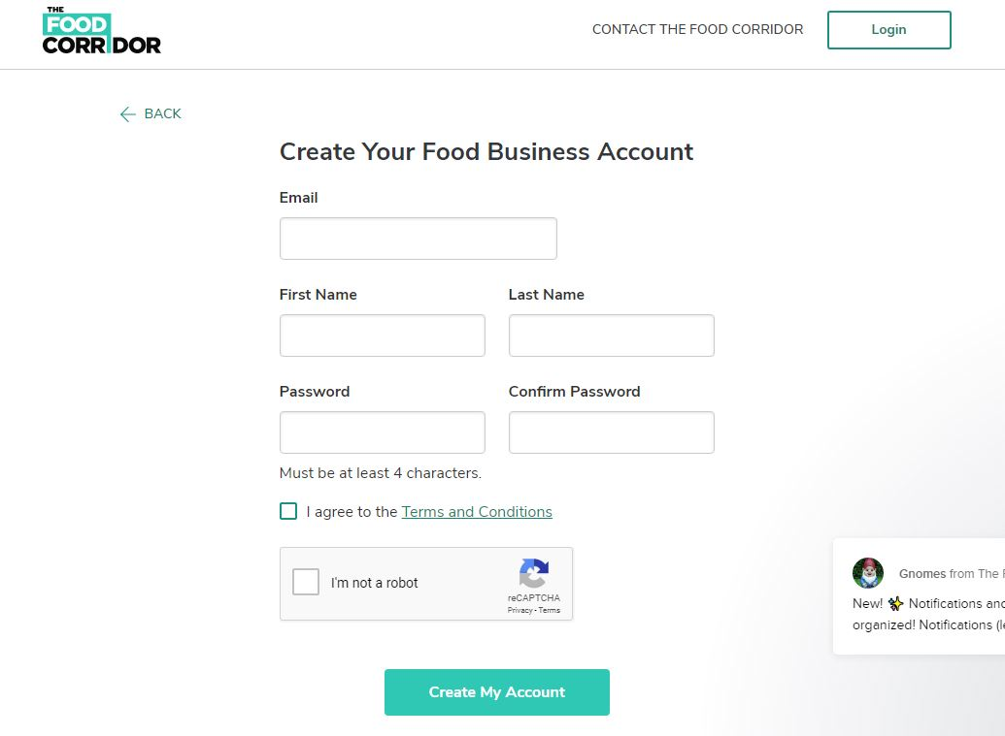

- After completing your business information, you will land on the following page prompting you to enter your billing information.
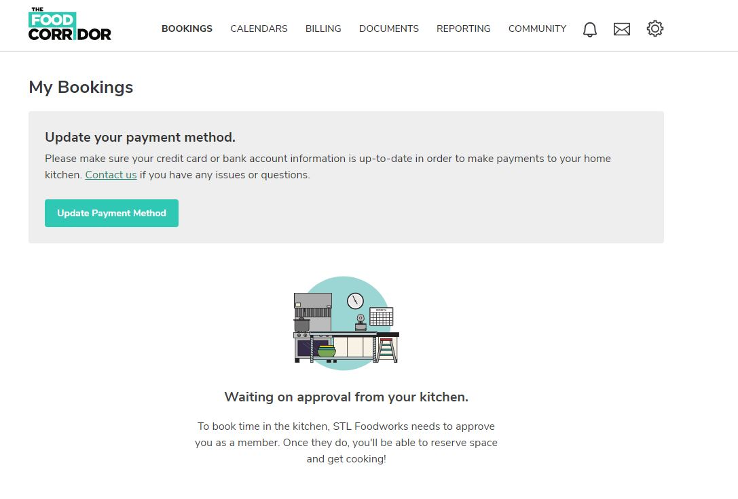
- Upload a copy of your Business License, ServSafe Certification and insurance documentation (the insurance requirements will be communicated to you by STL Foodworks management).

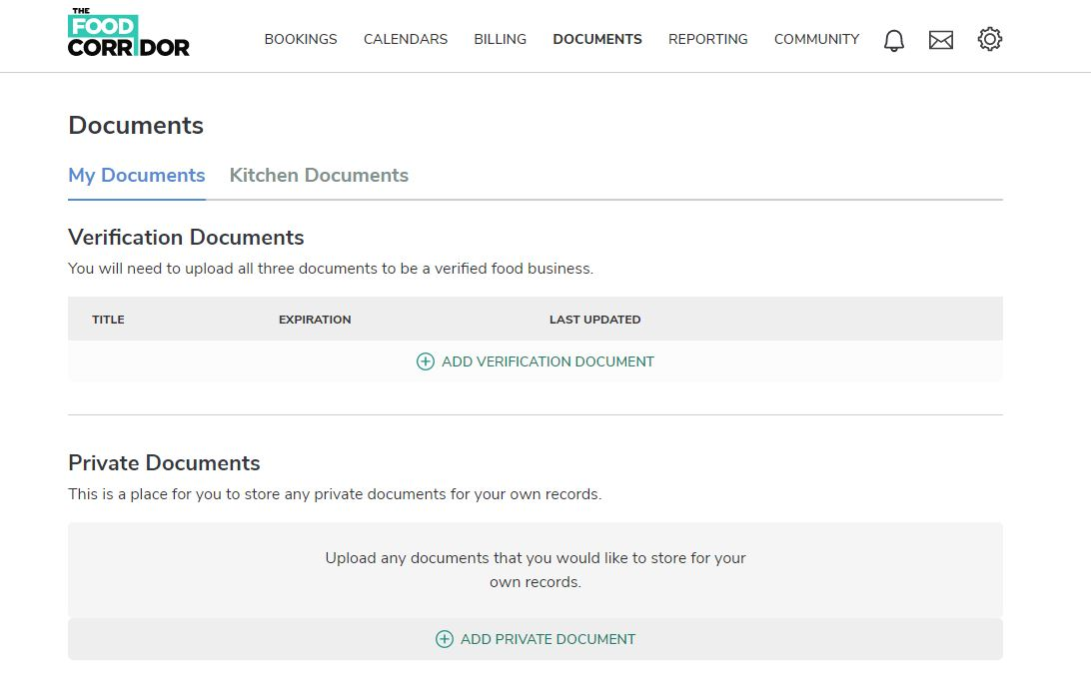

  - STL Foodworks management will then review your account. Management will reach out directly for any issues with your documentation. If all documentation is in order, you will receive an email stating your Food Corridor account has been approved.

- After your account is approved, STL Foodworks management will charge the $50 application fee to your account. It will automatically withdraw at midnight on the day it is charged.
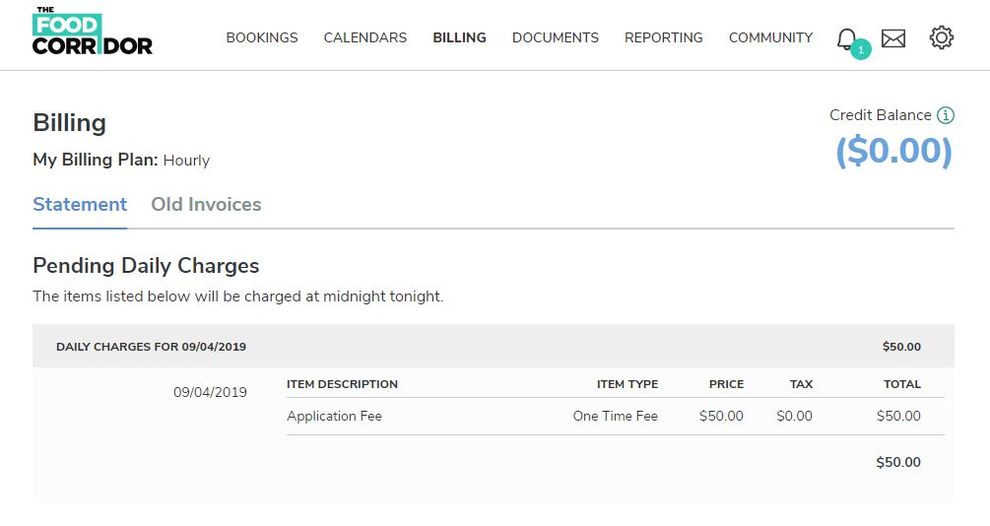

- Upload your initialed Policies and Procedures Manual.

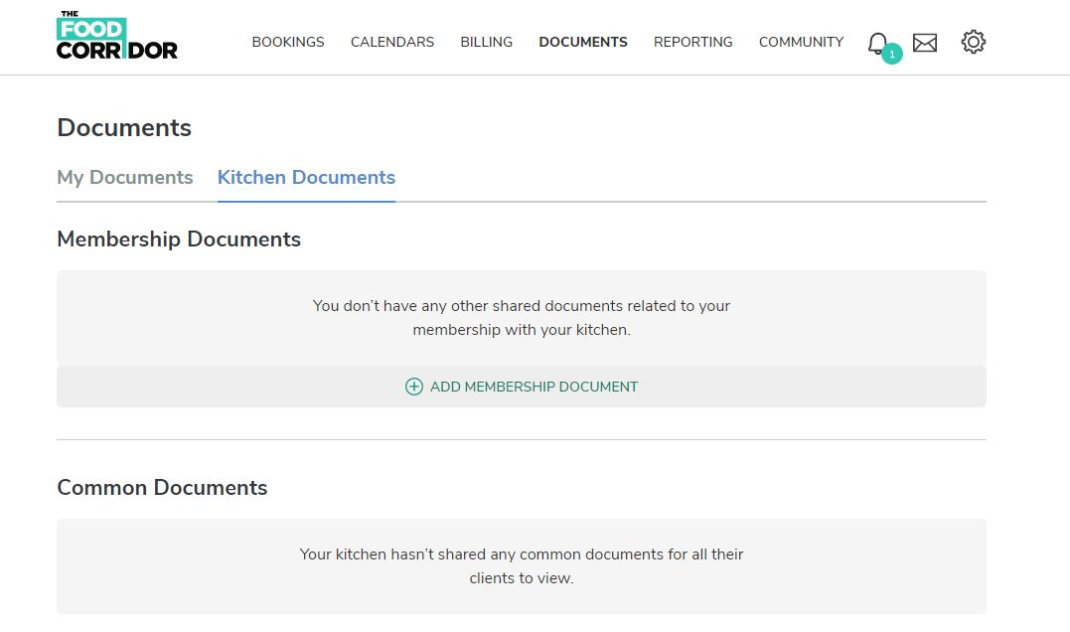

- Following final approval by STL Foodworks management, attendance at orientation and payment of the $300 refundable security deposit, you will be able to book kitchen space. The security deposit will be charged in the same manner as the application fee and will withdraw automatically at midnight of your orientation date.

