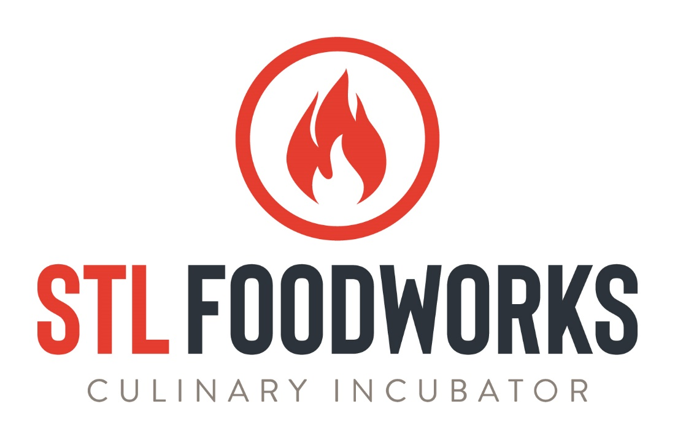
POLICIES AND PROCEDURES
August 2022

Purpose: The purpose of this manual is to provide users of STL Foodworks with information regarding our policies and procedures. Users are responsible for becoming familiar with all content and are expected to adhere to the policies and procedures within. Violation of these policies may result in fines and/or cancellation of services.
STL Foodworks will amend and release new versions of this document as the need arises. When a revision is made, the new policy and procedure manual will replace the old one on STL Foodworks’ website. A “Revised Date” will appear on the cover page. At any point in time, the current version of the document will be available from STL Foodworks management. Clients will receive communication anytime this document is updated.
Requirements to Use STL Foodworks: Before reserving kitchen time with STL Foodworks, clients must:
- Contact Us: Interested users of STL Foodworks should submit the online interest form (located at www.stlfoodworks.com) OR contact our office at (314) 833-3432 to schedule a site visit to be sure that we can accommodate your production needs.

- Apply: Complete the New Renter Application Form online at www.stlfoodworks.com.

- Sign Up and Submit Primary Paperwork: Set up your Food Corridor account using the link provided by STL Foodworks management. Upload a copy of your Business License, ServSafe Certification and insurance documentation to your Food Corridor account. STL Foodworks management will communicate the insurance requirements.
  - STL Foodworks management will then review your application and paperwork for approval. Management will reach out directly for any issues with documentation. You will receive an email stating your Food Corridor account has been approved.

- Pay Application Fee and Submit Secondary Paperwork: After approval, STL Foodworks management will charge the $50 application fee to your account. It will automatically withdraw at midnight on the day it is charged. Upload your initialed Policies and Procedures Manual to your Food Corridor account.

- Attend Orientation: A mandatory facility orientation and training course is offered free of charge to STL Foodworks users. Call or email to schedule orientation. Allow 30-45 minutes. Sign final paperwork (provided by STL Foodworks management) and pay the $300 refundable security deposit. The security deposit will be charge in the same manner as the application fee and will withdraw automatically at midnight of your orientation date.
Premises: Premises (defined as the whole building and total parking surface, including sidewalks and alleys) are to be used for food related business only.
Code of Conduct: Our goal is to provide a pleasant working environment for our clients as well as for our employees. All employees, customers, vendors and business associates should be treated with courtesy and respect at all times. Individuals on STL Foodworks premises are expected to refrain from fighting, “horseplay” or other conduct that may be dangerous to themselves or others. Conduct that threatens, intimidates or coerces another employee, customer, vendor or business associate will not be tolerated. STL Foodworks resources may not be used to threaten, stalk or harass anyone at or outside the workplace.
STL Foodworks treats threats coming from an abusive personal relationship as it does other forms of violence. Indirect or direct threats of violence, incidents of actual violence and suspicious individuals or activities should be reported as soon as possible to STL Foodworks staff. When reporting a threat or incident of violence, be as specific and detailed as possible. Do not intervene or attempt to intercede during an incident.
Unlawful activity is not allowed on the premises. Alcohol is allowed on the premises for use in recipes only. No consumption of alcohol is allowed on the premises. Fire arms are not allowed on the premises. Smoking or vaping must be done outside, at least 15 feet from the nearest entrance. Drug use is strictly prohibited on the premises.
Reservations: Reservations can be made through the Food Corridor. Reservations may be made up to 60 days in advance (no less than 24 hours in advance). Reservations must meet a four hour minimum. When booking, clients should ensure that they allow enough time for cleanup (see Cleaning Policies). After a reservation has been made and approved by STL Foodworks management, clients will receive an email confirming the space, date and time booked. Reminder emails will be received 24 hours before an approved reservation is scheduled.
Security deposit: A $300 security deposit is required at the time of orientation. This deposit is fully refundable provided that:
- The client has not incurred additional fees from kitchen use, which includes but is not limited to time overage and/or cleaning fees,

AND

- The space is left in the same state as when the client entered the space. This includes the kitchen being clean and all equipment in working order.
If these conditions are met to the satisfaction of STL Foodworks, the deposit will be refunded. Alternatively, clients may choose to leave the deposit on file for future bookings.
Payment: Payments for approved hourly reservations are automatically processed by the Food Corridor. The stored payment method will be charged on the day of the booking, at midnight, after the reservation is completed. (EX: A Monday morning booking will be charged on Monday night at midnight.) Monthly membership fees and storage rentals are billed on the 5th of the month. Clients will be able to review their monthly bills starting on the 3rd of the month.
Any additional fees incurred from kitchen use (i.e. time overages, cleaning fees) will be deducted from the security deposit and any remaining deposit balance will be refunded. Fees exceeding the security deposit will be billed through the Food Corridor and will automatically charge to the client’s account three (3) business days following the infraction. To dispute a fee, please contact STL Foodworks management. Continued infractions resulting in fees may cause cancellation of all further reservations. These reservations are subject to the cancellation policy below.
Credit and Debit Card payments: All electronic payments must be completed through the Food Corridor platform.
Payments by Check: STL Foodworks does not accept checks.
Discounted Rates: Discounted rates are available for monthly members and long-term tenants only.
Default: Client agrees to pay reasonable attorney fees and/or costs to collect, should third party collection be required.
Cancellation Policy: Reservations cancelled by the client fewer than 24 hours before the reservation’s start time are subject to a cancellation fee. The cancellation fee is equivalent to 50% of the initial reservation charge. Cancellation fees will be billed through the Food Corridor and will charge at midnight of the cancelled reservation’s date.
Unused Hours: Unused hours for the kitchens cannot be carried forward or refunded.
Other Fees: On occasion, it may be necessary to charge fees in addition to the money paid to use the kitchen. Such fees may include, but are not limited to kitchen time overages and cleaning fees.
If other fees are incurred, the additional fees will be deducted from the security deposit. Any remaining deposit balance will be refunded. Fees exceeding the security deposit will charged through the Food Corridor platform and must be settled at time of receipt. Fees not settled within five days of the date of charge will cause any remaining reservations to be cancelled. Such cancellations are subject to the terms of our cancellation policy above.
If other fees are incurred, the STL Foodworks client will receive a charge via the Food Corridor platform showing the amount due and the nature of the charge(s). These fees are charged through the Food Corridor platform and will automatically charge three (3) business days following the infraction. Clients will receive an email when fees are charged to their account. If reservations or privileges are cancelled due to non-payment for services or continued fee-bearing infractions, the client authorizes STL Foodworks to charge the amount owing to the credit or debit card on file OR subtract the amount from the client’s security deposit.
Facility Access: STL Foodworks is a secure facility. Access will be available through the front entrance when a manager is on premises. After-hours access will be available through the rear entrance using an access code. Upon completion of the required facility orientation and training course, an access code will be assigned according to the client’s facility use. Codes will change on a regular basis so check to confirm before your event. Interior and kitchen doors will not require keys or access codes.
Kitchen Time: Clients are expected to finish and clean within their reserved time. Please respect other clients using the space and plan appropriately. This means booking enough time for loading and unloading, prep time and time to clean. Any kitchen time overages will be charged to the client’s account under which the reservation was made. Clients are also expected to use only the kitchen space to which they are assigned. Failure to do so will result in a misuse fee and/or adjustment of the base rate for the reservation.
Storage: Clients will maintain their own storage areas (dry, cooler and freezer) in compliance with any and all regulatory agency’s policies and procedures, including, but not limited to, MO Department of Health and Senior Services, the MO Department of Agriculture and Good Manufacturing Practices. STL Foodworks reserves the right to end and inspect storage areas to ensure regulatory compliance. STL Foodworks does not take responsibility for lost or stolen items as a result of unlocked storage spaces.
Rule of thumb: Do not store anything on the floor. All items must be six inches off of floor or on casters, including oven racks and dish machine racks. All stored food items must be sealed or covered in plastic.
Parking: Street parking is available on N. Sarah St. and Westminster St. There is a dock for loading/unloading materials on the north side of the facility in the alley.

KITCHEN USE AND CLEANING POLICIES:
General Guidelines: Clients using STL Foodworks facilities are expected to follow all proper sanitation requirements as well as keep the kitchens, prep, dish machine and surrounding areas in a clean and professional state. Clients are also expected to properly clean and sanitize after each use, keeping the kitchens, prep, dish machine and surrounding areas ready for use by the next client. Our kitchens may be busy at times and it is important that the kitchens remain professional and clean for visitor, whether it is the health department, other (potential) clients, customers, service people, etc.
Appendix A is a quick reference for important, specific guidelines and requirements which must be followed at STL Foodworks (in addition to all standard sanitation expectations). Additionally, this section contains further details about specific kitchen uses and activities.
Additional Cleaning: If the clients does not clean the space in accordance with these guidelines, a cleaning fee will be imposed. This will be charged at the rate of $50 for the first occurrence and $150 thereafter. The additional fee will be subject to immediate payment.
Dish Washing: Proper dish washing and sanitizing is important for both public health and cost containment. Clients are expected to scrape into garbage, pre-rinse and follow the standard wash, rinse, sanitize procedure in the triple sink or dish machine (dish machine procedures are posted by the dish machine).
Scrape into the trash and pre-rinse all heavily soiled dishes, including large food scraps, greasy-buttery equipment, animal products, etc. This will make washing in the three-compartment sink or dish machine easier, as well as save costs associated with overuse of soap and sanitizer due to changing dirty dish water.
Use the triple sink for standard wash, rinse, sanitation of all dishes and equipment. When sink compartments become dirty or too cold, empty the compartment, clean the sink and refill as needed. However, scraping and pre-rinsing should keep this to a minimum.
Sweeping and Mopping Floors: Clients are expected to sweep the floors in all areas they use and mop up any spills. When finished mopping, empty the mop bucket, rinse and wring the mop and place it mop head up in the sink to dry. Do not leave dirty mop water in bucket. Do not store mop with head down in bucket. Replace broom and dustpan to the cleaning area. Be sure to sweep under and behind tables, sinks and equipment.
Wiping Down Equipment: Wipe down all equipment used at the end of your shift. Always use a clean rag, first with soap and water, followed by sanitizer solution. Be sure to wipe down the inside of ovens and coolers. If the stove is heavily soiled, remove the grates and wash in three compartment sink, otherwise wipe down the stove top if used. Be sure to remove any baked on spills from stove top and ovens.
Dumpsters: For rodent and pest control, all garbage is to be bagged and tied before being placed in the dumpster. No whole boxes in dumpster. Close all doors and lids after each use. There are many dumpsters on the north side of the STL Foodworks building. STL Foodworks clients are to use the green Waste Management dumpster closest to the loading dock.

SECURITY
Security is everyone’s responsibility! To promote safety of persons and property, observe the following:
Entrances: The front door to the facility will be open only when the manager is on premise. Clients will be able to access the facility via the alley entrance using their assigned access code. Loading/unloading should be completed at the alley dock, do not prop entry doors open to load/unload. Do not open doors for unexpected visitors.
Surveillance: The facility is under 24-hour video surveillance.
NOTE: Violation of any of our Policies and Procedures may result in an immediate fine, typically $50. Security and Regulatory related violations could carry high fines. Repeated violations will result in progressive disciplinary action up to and including revocation of facility access, privileges and termination of services.

Appendix A: Kitchen Use Policies Reference
Attire
- No sandals or open-toed shoes are to be worn by anyone using the kitchen, even when picking up or dropping off.
- Long pants must be worn at all times.
- Hair longer than shoulder length must be covered or tied back.
Health and Safety
- No eating in the kitchen. Drinks should be kept under the tables with lids/caps on them. Disregard if the kitchen is being used for a cooking demonstration or a cooking class.
- Persons exhibiting signs and symptoms of acute illness, including but not limited to, fever, productive cough, sneezing or eye drainage, are prohibited access to the facility as deemed appropriate by facility staff until such conditions have resolved.
- All cuts, open wounds and skin lesions must be covered with a dry bandage with all edges securely sealed to skin during facility use.
Sanitation and Cleaning
- Scrape into garbage and pre-rinse all heavily soiled dishes (large scraps, greasy/buttery bowls, ground, animal products).
- Wash all dishes and equipment in the 3-compartment sink (right to left: wash, rinse, sanitize) or dish machine (instructions posted next to machine).
- Follow all proper sanitary guidelines for preparation of meat, including proper sanitization of equipment, tables, etc.
Finishing
- Be sure that all equipment is clean for the next person that will be using the kitchen, making sure to remove baked on spills.
- Wipe down and sanitize all counter, tables, sinks & equipment (doors, handles, knobs, controls, bases, etc.) using sanitizer and a clean towel. Don’t forget the stovetop and the inside of ovens.
- Sweep and mop all areas in which you have been working.
- Take out your trash. Trash bags should be tied and placed in the large dumpster in back.
- Empty any trash that has spilled outside of a bag into the garbage can. Replace all trash bags with clean bags.
- Clean and break down all cardboard/paper boxes before placing in dumpster.

ACKNOWLEDGEMENT OF RECEIPT AND REVIEW

I acknowledge that I have been provided a copy of the STL Foodworks Policy and Procedures. I have read and been informed about the content, requirements and expectations for clients of STL Foodworks. I agree to abide by the policy guidelines as a condition of use of STL Foodworks facilities. I accept that violation of these Policies and Procedures will result in disciplinary action (including fines and/or termination of service). I understand that the policy guidelines apply to myself and anyone working with or for me inside of the facility.

I understand that if I have questions, at any time, regarding the STL Foodworks Policy and Procedures, I will consult with STL Foodworks management.

Please read the Policies and Procedures carefully to ensure that you understand the policy before signing this document.

_____________________________________
Signature

_____________________________________
Printed Name

______________________________________
Company Name

______________________________________
Date

